

|  |  |  |  |  |  |  |  |  |
| --- | --- | --- | --- | --- | --- | --- | --- | --- |
|  | | | | | | | | |
|  | | Week 8 Adventure Works Cycle | | | | |  | |
|  |  | | | | | | |  |
|  | | | |  |  | | | |
|  | | | | Christine Baxter |  | | | |
|  | | | | August 28, 2021—Developing and Managing Databases for Business IntelligenceBIAM530—Robert Burdwell |  | | | |
|  | | |  | | |  | | |



|  |  |  |  |  |  |  |  |  |
| --- | --- | --- | --- | --- | --- | --- | --- | --- |
|  |  | | |  |  | | |  |
|  | Abstract | | | | | | |  |
|  |  | | |  |  | | |  |
|  |  | |  | | |  | |  |
|  |  | Big Data is here to stay and will continue to grow over the next five years. Many companies have turned their focus onto their big data environments, ensuring the organizations have the right tools, processes, skill, and knowledge in place to provide and/or keep a competitive advantage. Big Data, if implemented appropriate, can be used by all levels of the organization for data-based decisions. Let big data work for you by understanding/utilizing big data tools and concepts. | | | | |  |  |
|  | | | | |
|  |  |  |  |
|  |  |

|  |  |  |  |  |  |  |  |  |  |  |  |  |  |
| --- | --- | --- | --- | --- | --- | --- | --- | --- | --- | --- | --- | --- | --- |
|  | | | | | | | | | | | | | |
|  | | | Introduction | | | | |  | | | | | |
|  | | |  | |  |  | |  | | | | | |
|  | | Big data, NoSQL, MongoDB, Hadoop, Spark, Power BI …these are buzz words that have been running throughout the organization over the last year. To keep a competitive advantage, the Executive Leadership team feels it is important to improve the company’s big data environment.  To enhance this focus and commitment, the executive leadership team has initiated a company-wide project with the desired outcome of significantly improving our big data functionalities and/or capabilities as well as the management team’s overall knowledge of how NoSQL databases work within the company. The discussion will start on NoSQL databases, covering what a NoSQL database is with emphasis on the MongoDB and Neo4J databases.  Next, we will learn about differences between Hadoop and Spark through examples and discussion on how these tools assist in the Big Data concept. Further discussion and explanations will be covered on various tools available within our environment including potential issues/opportunities for handling unstructured data in each of the specified environments. This report will conclude with a business intelligence (BI) tool recommendation. | | | | | | | | |  | | | |
|  | | | | | | | | | | | |
|  | | | | NoSQL Database | | |  | | | | |
|  | | | |  |  |  |  | | | | |
|  | What is a NoSQL Database? NoSQL at a high-level covers a wide array of nonrelational database technologies developed for addressing the Big Data challenges that companies are/have been facing. The technologies generally fit into one of four categories: key-value database, document database, column-oriented database, and graph database (Coronel & Morris, 2019). As noted in Table 14.3 below, MongoDB and Neo4J fall under two different categories. One is a NoSQL document database (MongoDB) and the other is a NoSQL graph database (Neo4J). Let’s learn more about both databases.  A picture containing timeline  Description automatically generated | | | | | | | | |  | |
|  | | | | | | | | | | | |
|  | | | | NoSQL Database | | |  | | | | |
|  | | | |  |  |  |  | | | | |
|  | NoSQL Database - MongoDBDocument databases such as MongoDB store data using key-value pairs and the value component always stores a tag-encoded document (Coronel & Morris, 2019). Unlike Key-value (KV) databases, document databases understand the content of the value component and tagging is used for identifying named portions of the documents. Querying on tags is possible within document databases since the database management system (DBMS) is aware of the tags within the documents. MongoDB was developed to support extremely large data sets and designed for high availability, high scalability, and high performance. Lastly, MongoDB is a schema-less and aggregate aware document database.NoSQL Database - Neo4J Graph databases such as Neo4J represent data through nodes (entity instance), edges (relationships between nodes), and properties (attributes describing corresponding node/edge) (Coronel & Morris, 2019). The graph databases are also based on graph theory which is a well-established, mathematical and computer science field of study for modelling relationships. These type of database models are used with complex relationships among entities and, as a result, excel at tracking relationship-intensive data, such as social media data. Now that we know more about NoSQL databases such as MongoDB and Neo4J, we will move onto the differences between Spark and Hadoop. | | | | | | | | |  | |
|  | | | | | | | | | | | |
|  | | | | Spark and Hadoop | | |  | | | | |
|  | | | |  |  |  |  | | | | |
|  | Spark and Hadoop - Differences Spark is an enhancement to Hadoop’s MapReduce process (IBM Cloud, 2021). More specifically, Spark processes/retains data within memory and MapReduce processes data on disk. When comparing Spark and Hadoop further…Spark is faster, ideal for real-time and live unstructured data stream processing, and is the superior platform for machine learning (ML); however, it does run at a higher cost, relies on Hadoop Distributed File System (HDFS) fault tolerance for scalability, and has lower level of security unless integrated with Hadoop for a higher security level. Spark and Hadoop - Examples Hadoop works best when…processing large data sets where data size exceeds available memory, completing non time-sensitive jobs, and building data analysis infrastructure with limited budget (IBM Cloud, 2021). Spark is best for…achieving quick results with in-memory computations, analyzing stream data analysis in real time, and all ML applications. Spark and Hadoop - Big Data Concept Hadoop supports advanced analytics for stored data, enabling big data analytics processing tasks to be split into smaller tasks that are performed in parallel by using an algorithm such as MapReduce (IBM Cloud, 2021). Spark’s framework combines data and artificial intelligence (AI), enabling users to perform large-scale data transformation and analyses, and then running ML and AI algorithms. Our next step is to discuss unstructured data options as they relate to the company’s available tools. | | | | | | | | |  | |
|  | | | | | | | | | | | |
|  | | | | Review of Available Tools | | |  | | | | |
|  | | | |  |  |  |  | | | | |
|  | Unstructured Data Options Microsoft (MS) SQL Server is a relational database management system (RDBMS) that was initially built for structured data and this technology has been around for many years now; however, support for JSON data storage and text processing were added (or tacked on) within their 2016 release (Hazel, 2021). As a result, MS SQL Server is not a true multiple model data platform. This is where Power BI/Tableau, Hadoop, RoboMongo, and Neo4j come into play as these items were purpose-built for storing and querying of semi-structured and unstructured data. Hadoop/MapReduce is a processing engine used for large-scale storing and distributed processing of semi-structured and unstructured data across a distributed file system. RoboMongo/MongoDB, a document database, and Neo4j, a graph database, are NoSQL (non-relational) databases that can be used for the storing and querying of semi-structured and unstructured data. Power BI and Tableau are business intelligence software applications that produce interactive visualizations/dashboards by accessing structured, semi-structured, and unstructured data from many data sources. Structured MS SQL Example versus Unstructured Example When viewing the SQL statements and results that were created/implemented with MS SQL Server, you can easily see the structured data and how it is used. As a refresher, structured data is a neat organization of components in a predetermined manner and stored in tables with rows and columns (AltexSoft, 2020). For example, using structured query language (SQL) the system was able to access the structured data within the SalesTerritory | | | | | | | | |  | |
|  | | | | | | | | | | | |
|  | | | | Review of Available Tools | | |  | | | | |
|  | | | |  |  |  |  | | | | |
|  | table of the Sales database summing the year-to-date and last-year sales then grouping by country region (Figure 1). Within Figure 2. Best-Selling Products with Product Names (MS SQL Server vs. Power BI), again using SQL, we were able to use the structured data from multiple database tables to sum, group, and sort data. Unstructured data is not as easy to search/store since it consists of a huge variety of formats, does not have a pre-defined data model, and is stored within non-relational databases. For example, unstructured data can be found in emails, social media posts, images, audio, or sensor data (refer to Figure 3. Travel Agency Facebook Post: Example of Unstructured Data for example). Unstructured Data Issues/Opportunities MS SQL Server works best for structured data, its development platform is strongly coupled with other MS products, or the company already has MS-SQL databases and would prefer to lift-and-shift those databases into Cloud (Kamaruzzaman, 2021). However, MS SQL Server is not ideal for companies with lower budgets for databases, are managing semi-structured data that needs advanced query operations, or when distributed SQL databases are desired.  RoboMongo/MongoDB works best when data is document or semi-structured such as JSON, XML with advanced query features, data is schema-less, consistency is preferred over availability for semi-structured data or for fast application development where the schema is continuously changing (Kamaruzzaman, 2021). However, MongoDB is not | | | | | | | | |  | |
|  | | | | | | | | | | | |
|  | | | | Review of Available Tools | | |  | | | | |
|  | | | |  |  |  |  | | | | |
|  | ideal to use for structured data, data warehousing, or when high availability is preferred over consistency or when multi-master write is needed for write-heavy loads.  Neo4j works best for showing results in real time, having query speed dependent on number of relationships and not on amount of data, providing clear and manageable relationship representation, its flexible and agile structures; however, it is difficult to scale since designed as one-tier architecture and has no uniform query language (IONOS, 2019).  Hadoop ecosystem is scalable, cost-effective, flexible, fast, and resilient to failure (Sharma, 2018). However, it is not ideal for performing in small data surroundings due to decrease in efficiency, has a lack of security since the default security feature is made un-available, supports only batch processing, and is likely to have vulnerability due to framework being written in java which happens to be one of the most used programming languages (Sharma, 2018).  Tableau works well for creating visuals, enabling report and story creation, and the artificial intelligence (AI) driven insights and statistical engine are powerful right out-of-the-box; however, its lack of natural language processing (NLP) search analytics, open-source custom visualizations, and affordability for small to medium companies including the added costs for governance and data movement/transformation tools can be very challenging (Petrossian, 2021).  Power BI can be connected to many data sources, reading data from Excel and text files like XML and JSON, has robust AI visualizations and capabilities, provides more | | | | | | | | |  | |
|  | | | | | | | | | | | |
|  | | | | Review of Available Tools | | |  | | | | |
|  | | | |  |  |  |  | | | | |
|  | affordability with named-license-based purchase options, and updates are released monthly ensuring access to the latest and greatest features/fixes (Petrossian, 2021). However, the many layers of Power BI can get complicated for some users, learning DAX (calculation language) is needed for utilizing the most advanced features of the software, and deploying Power BI is easier the more a company’s infrastructure is embedded with Microsoft. Business Intelligence Tool Recommendation After reviewing several business intelligence (BI) tools and knowing the company prefers to utilize their Microsoft infrastructure, we recommend that the business implement Power BI as their analytics tool. With Power BI, the company can produce interactive dashboards and rich reports, consolidating key metrics and connecting datasets from workloads (Microsoft, 2021). This BI tool will pull data from a wide variety of sources (structured, unstructured, semi-structured), allowing better and smarter data-driven decisions. Using Power BI, the company can prepare/model data, engage in data discovery, and provide interactive dashboards and self-service capabilities all in one solution. MS SQL Server, MongoDB, Neo4j, Hadoop, and Tableau are all very good BI tools; however, they each have limitations when it comes to multiple model support and learning curve for the organization. With Power BI, the organization has ability to connect to any of the previously mentioned systems and use that data for real-time visualizations/dashboards without the need to migrate into another system. | | | | | | | | |  | |
|  | | | | | | | | | | | |
|  | | | | Review of Available Tools | | |  | | | | |
|  | | | |  |  |  |  | | | | |
|  | The company’s IT department is already familiar with Microsoft’s infrastructure including licensing and costing which will provide a lower learning curve for that department (Zaact Consulting, 2021). Data security is a high priority, and this solution will use industry-leading data security capabilities that include sensitivity labeling, end-to-end encryption, and real-time access monitoring. Lastly, using Power BI will enable the business to (1) produce better stories with the software’s Timeline Storyteller tool; (2) ask questions and receive visualization responses using the NLP feature; (3) produce smarter executive dashboards providing the right amount of detail for the various user groups; (4) ensure they have the right visualization for their stories/dashboards with the ability to customize existing graphs/charts or create their own, company-specific graphs/charts; and (5) the IT department can use Power BI for visualizing their Azure IT Data enabling them to view trends in usage and problems. | | | | | | | | |  | |
|  | | | | | | | | | | | | |
|  | | | | Conclusion | | |  | | | | | |
|  | | | |  |  |  |  | | | | | |
|  | | Conclusion As you can see there is much information to learn when it comes to Big Data. With this report, we covered NoSQL databases, covering what a NoSQL database is with emphasis on the MongoDB and Neo4J databases. Then we learned about Hadoop and Spark differences through examples and discussion on how these tools assist in the Big Data concept. Further discussion and explanation were had on various tools available within the company’s environment including potential issues/opportunities for handling unstructured data in the MS SQL Server, RoboMongo/MongoDB, Neo4j, Hadoop ecosystem, Tableau, and finally, Power BI environments. This report concluded with a business intelligence (BI) tool recommendation. | | | | | | |  | | | |
|  | | | | | | | | | | | | |
|  | | | | FIGURE(S) | | | |  | | | | |
|  | | | |  |  |  | |  | | | | |

Figure 1. Sales by Country (MS SQL Server vs. Power BI) 14

Figure 2. Best-Selling Products with Product Names (MS SQL Server vs. Power BI) 15

Figure 3. Travel Agency Facebook Post: Example of Unstructured Data 16

Figure 4. MongoImport Command Line Action 17

Figure 5. RoboMongo db.getName(); Function 17

Figure 6. RoboMongo show collections Method 17

Figure 7. MongoDB find() Query Statements Screenshot 1 18

Figure 8. MongoDB find() Query Statements Screenshot 2 19

Figure 9. MongoDB find() Query Statements Screenshot 3 20

Figure 1. Sales by Country (MS SQL Server vs. Power BI)

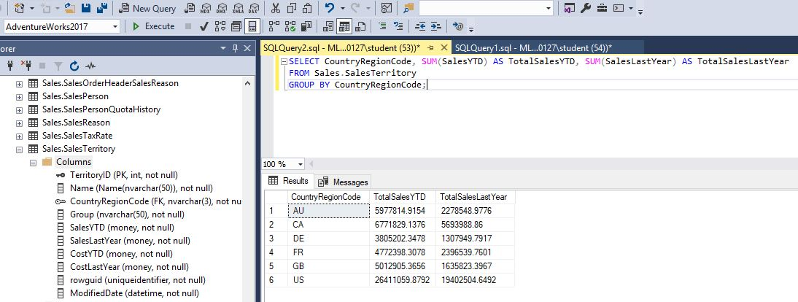

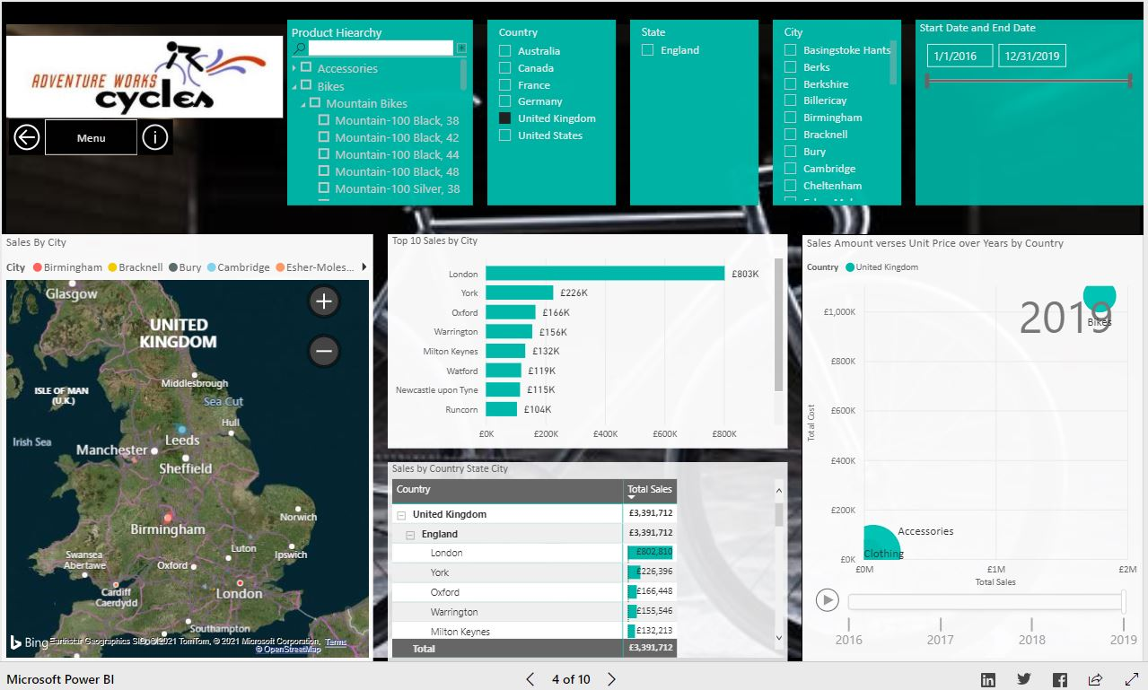

Source: (Wood, 2019)

Figure 2. Best-Selling Products with Product Names (MS SQL Server vs. Power BI)

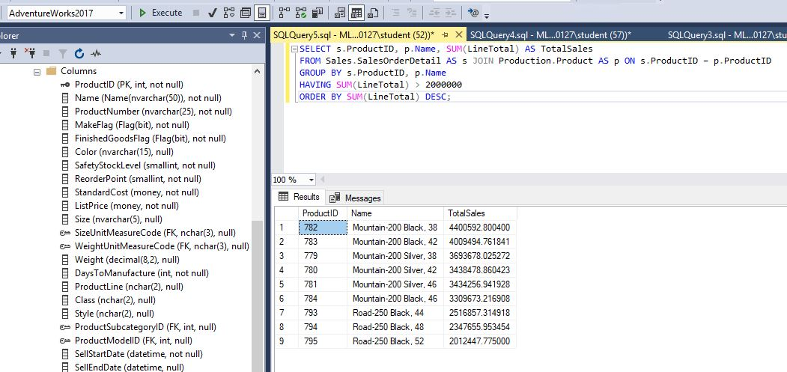

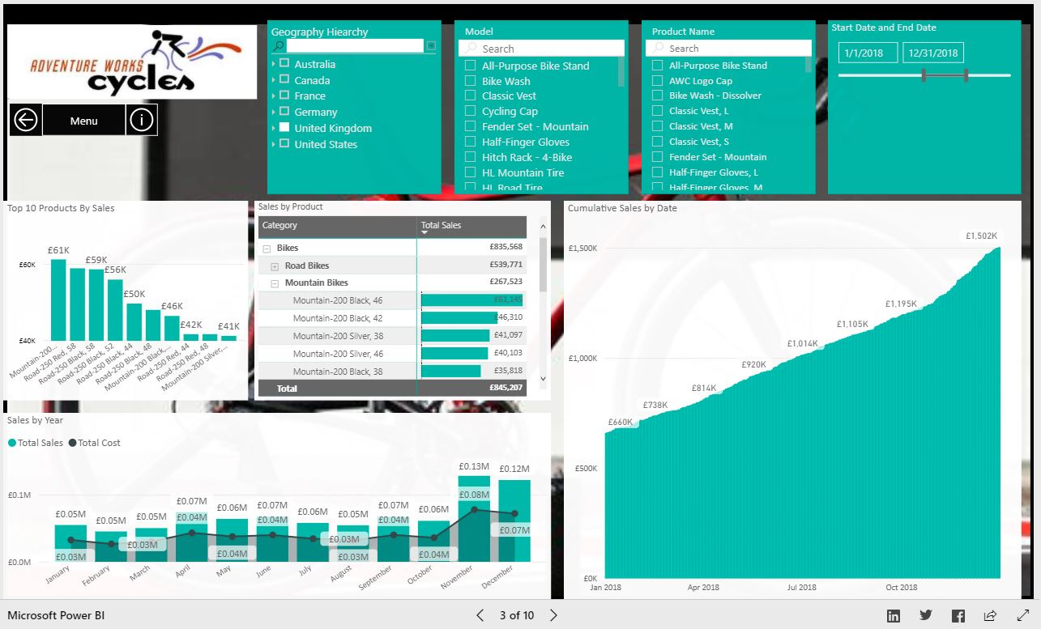

Source: (Wood, 2019)

Figure 3. Travel Agency Facebook Post: Example of Unstructured Data



Source: (AltexSoft, 2020)

Figure 4. MongoImport Command Line Action

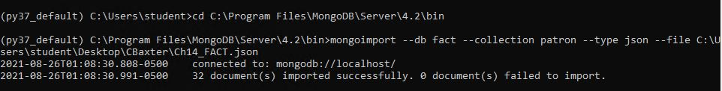

Figure 5. RoboMongo db.getName(); Function

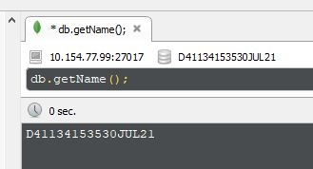

Figure 6. RoboMongo show collections Method

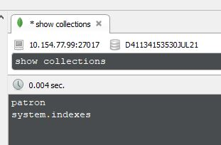

Figure 7. MongoDB find() Query Statements Screenshot 1

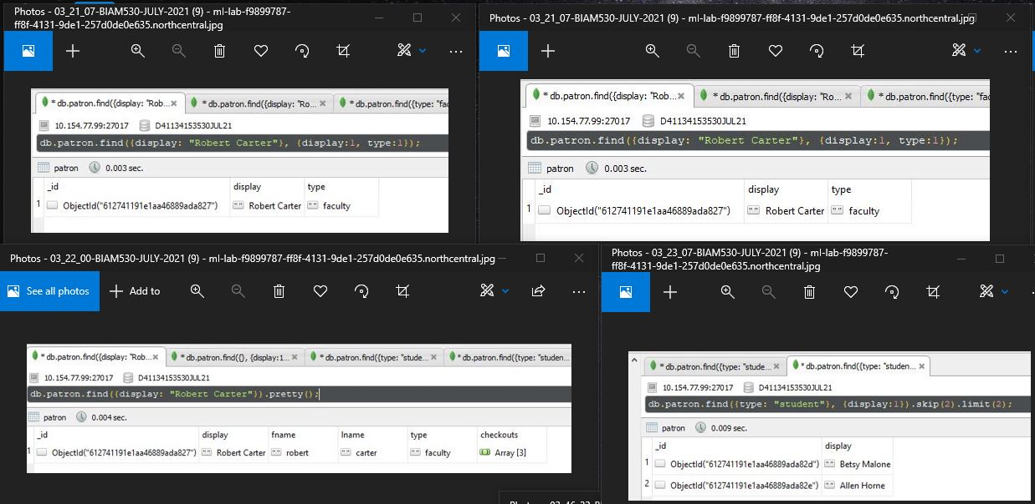

Figure 8. MongoDB find() Query Statements Screenshot 2

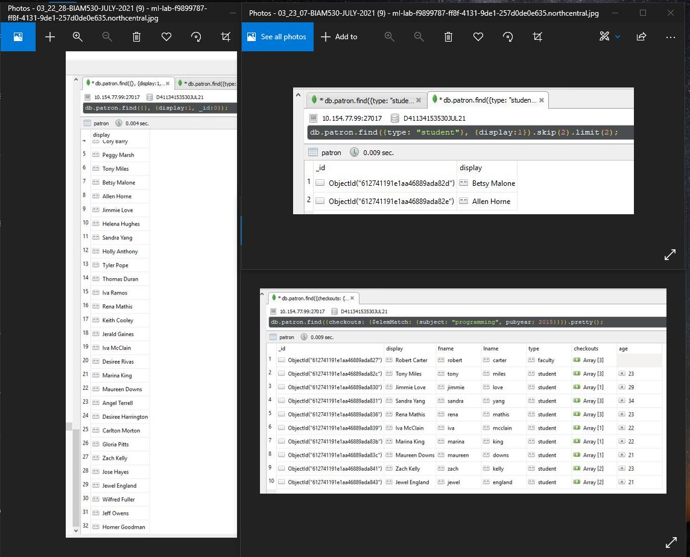

Figure 9. MongoDB find() Query Statements Screenshot 3

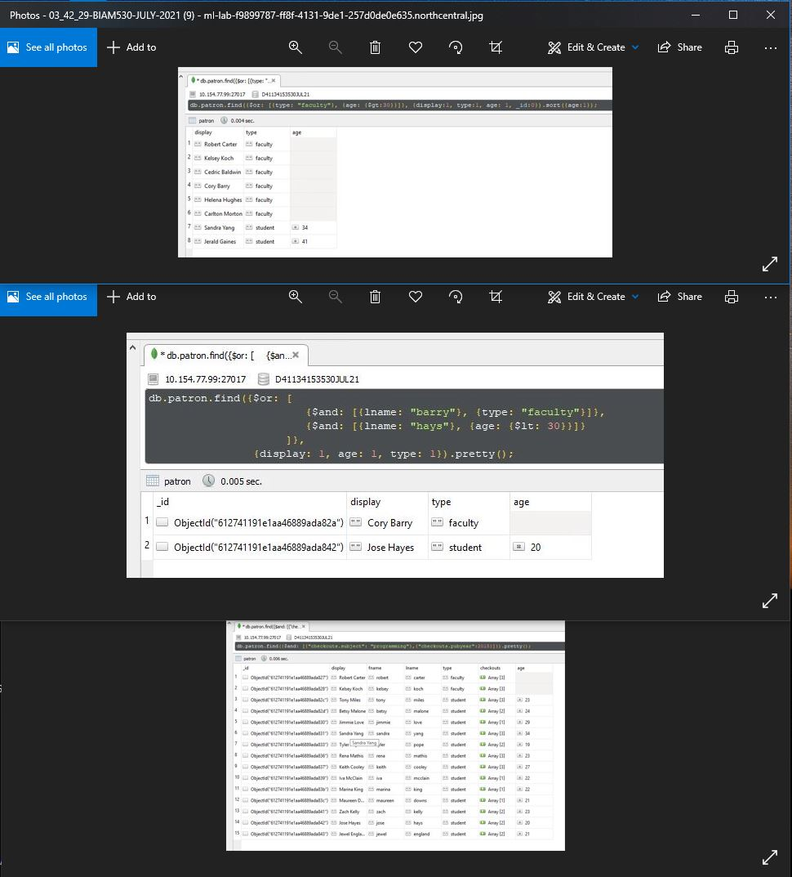

|  |  |  |  |  |
| --- | --- | --- | --- | --- |
|  | | | | |
|  | References | | |  |
|  |  |  |  |  |
| AltexSoft. (2020, Dec 14,). Structured vs unstructured data: Compared and explained. <https://www.altexsoft.com/blog/structured-unstructured-data/>  Coronel, C., & Morris, S. (2019). *Database systems: Design, implementation, & management* (13th ed.). MindTap - Cengage Learning.  Hazel, T. (2021, ). Why enterprises need a true multi-model platform. <https://www.chaossearch.io/blog/why-enterprises-need-a-true-multi-model-platform>  IBM Cloud. (2021). *Hadoop vs. spark: What's the difference?* <https://www.ibm.com/cloud/blog/hadoop-vs-spark>  IONOS. (2019). *Graph databases explained.* <https://www.ionos.com/digitalguide/hosting/technical-matters/graph-database/>  Kamaruzzaman, M. (2021). *Top 10 databases to use in 2021.* <https://towardsdatascience.com/top-10-databases-to-use-in-2021-d7e6a85402ba>  Microsoft. (2021). *Data visualization | microsoft power BI.* <https://powerbi.microsoft.com/en-us/>  Petrossian, G. (2021, May 27,). Business intelligence tools: A pros and cons comparison chart. <https://www.csgpro.com/blog/business-intelligence-tools-comparison-chart/>  Sharma, S. (2018). *Hadoop key features and its advantages | K21 academy.* <https://k21academy.com/big-data-hadoop/hadoop-key-features-advantages/>  Wood, K. (2019). *Power BI best practice recommendation.* <https://community.powerbi.com/t5/Data-Stories-Gallery/Power-BI-Best-Practice-Recommendation/m-p/745072#M2786>  Zaact Consulting. (2021). *Why power BI? 5 ways businesses use power BI.* <https://zaact.com/why-power-bi-5-ways-businesses-use-power-bi/> | | | | |